Sit next to your partner.

Take turns talking and listening.

Listen carefully and use eye-contact.

Build a conversation:




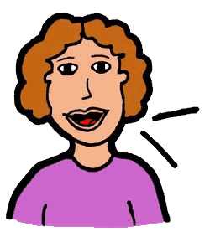
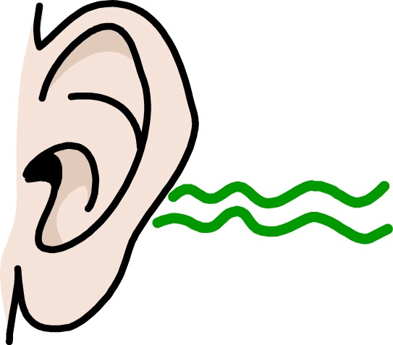
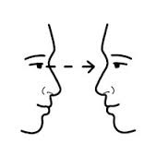

I agree/disagree with you because _____________.
Turn and Talk
Where did you see that in the text?
How do you know?/Why do you say that?
The text says _________, so ___________.
Why do you think that?
Now that you said _____________, I think _________.

